VAN HARGIS HORSEMANSHIP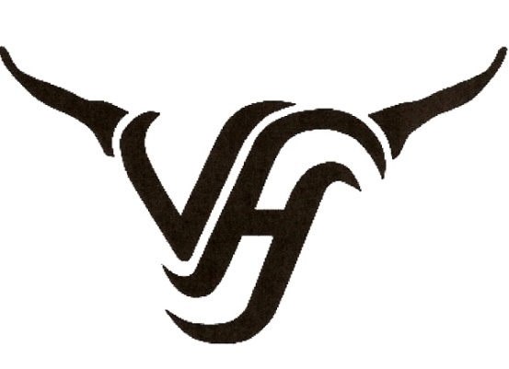

A 2 day Van Hargis Horsemanship Clinic will actually start with an orientation on the evening prior to the clinic. Typically Friday around 6pm. Participants are able to settle their horses into the facility and meet the other riders. Van likes to meet with the participants in order to get an idea of what questions & goals everyone has.
Saturday and Sunday will be 2 full days of instructions & direction with and hour for lunch each day. Van does not have a specific format for his horsemanship clinics. He will tailor the clinic towards the topics/problems/questions that everyone would like to address. Van will work with the participants in order to help them achieve their goals. During the lunch breaks, Van will discuss tack & equipment and will also answer questions. He encourages participation from both the riders and the clinic auditors. Van’s clinics are very thorough and are designed to teach participants well rounded horsemanship skills.

